6.24: a) Gravity acts in the same direction as the watermelon’s motion, so Eq. (6.1) gives

b) Since the melon is released from rest, 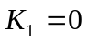, and Eq. (6.6) gives

